Introduction to MS SQL-Server

Homework

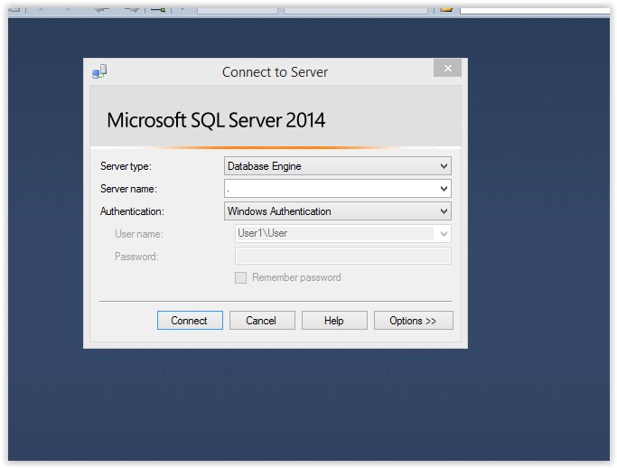  
  
// Task 2- **Connect to the SQL Server with SQL Server Management Studio. Use Windows authentication.**

// Task 3- **Create a new database Pubs and create new login with permissions to connect to it. Execute the script install pubs.sql to populate the DB contents (you may need slightly to edit the script before).**

1. **Create a new database-** Right-click on the Databases folder and select "New Database”.  
     
   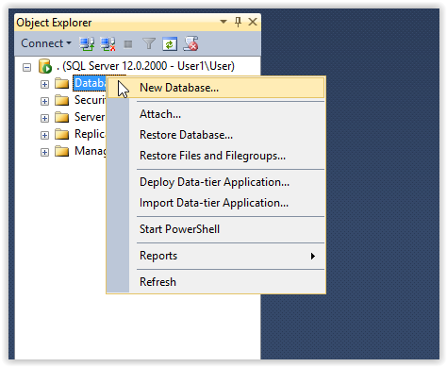   
     
     
    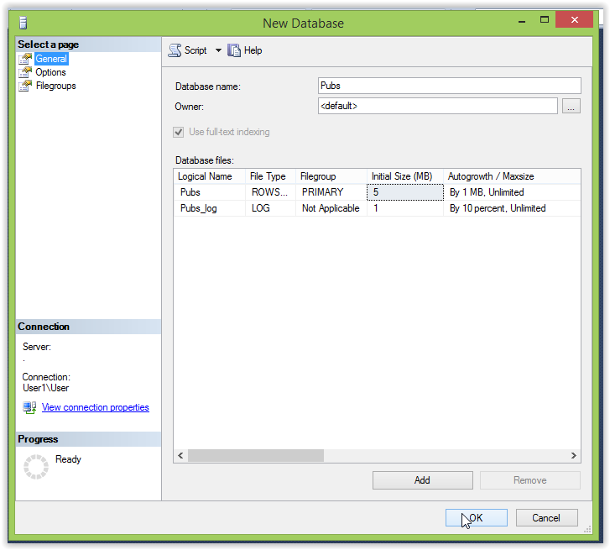

1. **Create a table -** Right-click on the Table folder and select "Table…”. 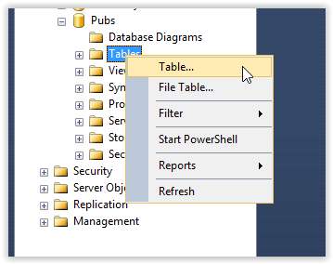
2. **Create new login -** Right-click the **Security** folder, point to **New**, and select **Login  
     
   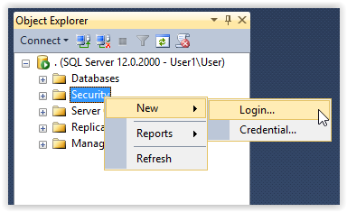**// Task 4- **Attach the database Northwind (use the files Northwind.mdf and Northwind.ldf) to SQL Server and connect to it.  
     
   Attach the database-** Right-click on the Databases folder and select "Attach…”.

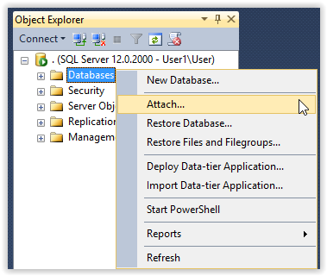

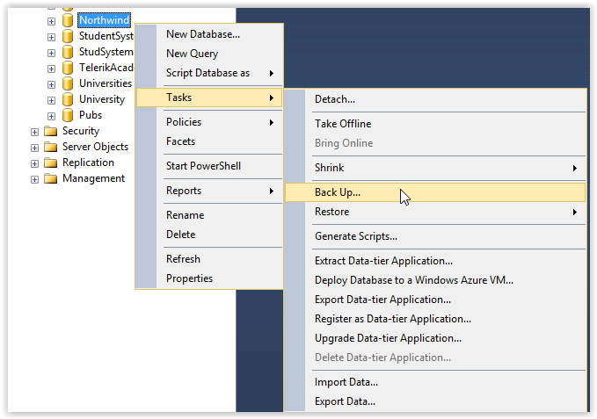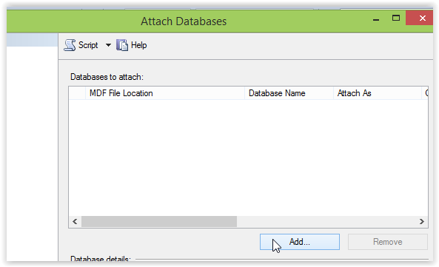

**Backup the database-** Right-click the database which you want to take a full backup and point to Tasks, and then click Back Up…

Click “Add…” and then find your file Northwind.mdf

// Task 5 - **Backup the database Northwind into a file named northwind-backup.bak and restore it as database named North.**

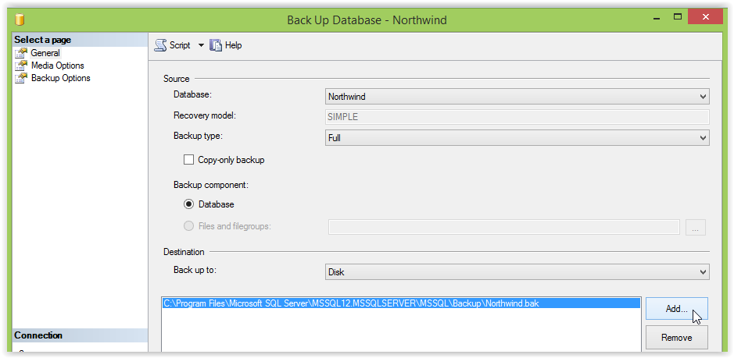

Click on button “Add..” and choose where to save your backup file

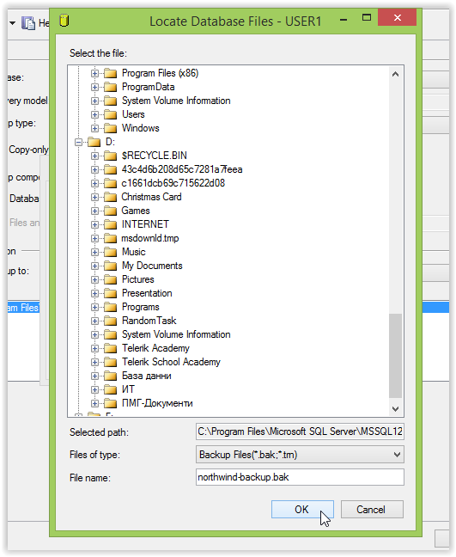

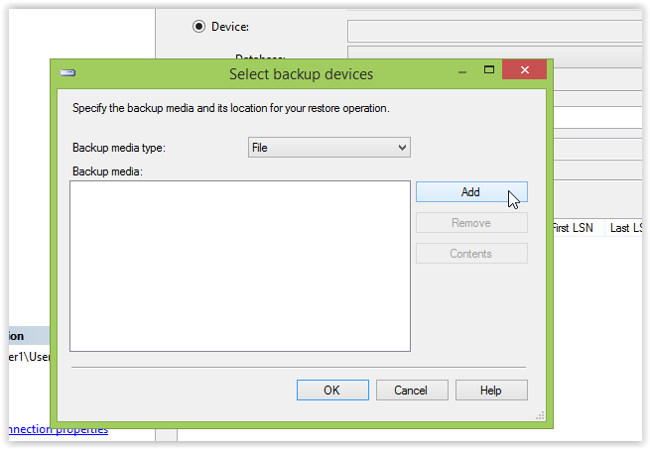  
  
  
  
  
  
  
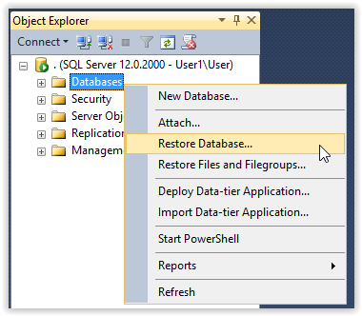  
  
  
  
  
  
  
  
  
  
  
  
  
  
  
  
  
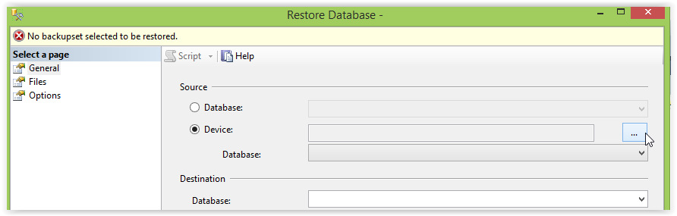

**Restore database-** Right-click on the Databases folder and select "Restore Database…”.

In ’Restore Database’ Dialog will be displayed on the **General** page

1. Select “Device” then click on “…”  
2. Click ‘Add’  to browse the .bak file from the directory and click OK